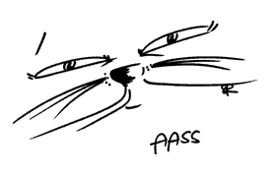

VENERDI 10 AGOSTO 2012 – CAPANNONE AASS – SOBRIO sponsored by:

Formulario d’iscrizione

Dati personali:

Cognome: | Nome:
Indirizzo: | Domicilio:
Nazionalità: | Età:
N° telefono cellulare: | E-mail:
Per i candidati minorenni indicare i dati anagrafici di un genitore (che dovrà pure sottoscrivere il formulario in segno d’approvazione)
Cognome: | Nome:
Indirizzo (se diverso da sopra): | Domicilio (se diverso da sopra):
N° telefono cellulare: | E-mail:
Descrizione, nella maniera più dettagliata possibile, del tipo e dei contenuti dell’esibizione:
____________________________________________________________________________________________________________________________________________
____________________________________________________________________________________________________________________________________________
____________________________________________________________________________________________________________________________________________
____________________________________________________________________________________________________________________________________________
____________________________________________________________________________________________________________________________________________
____________________________________________________________________________________________________________________________________________
____________________________________________________________________________________________________________________________________________
Supporti tecnici necessari:
____________________________________________________________________________________________________________________________________________
____________________________________________________________________________________________________________________________________________
Inviare il seguente tagliando via e-mail all’indirizzo morenobertazzi@bluewin.ch oppure via Posta all’indirizzo: Moreno Bertazzi – Via Orbello 13 – 6517 Arbedo
entro il 30 giugno 2012.

Luogo e data: ________________________________________________________ Firma: _______________________________________________

